**Database Systems and Database Systems Design**

**Term Project: For Thai Tour Agency**

Members

Mrs. Nuthathai Poolsawat 662115029

Mrs. Ninlawan Bamrungpol 662115030

Mr. Wasasart Ratchaneerom 662115046

Instructor

Mr. Pree Thiengburanathum

This project is a part of the course Database Systems and Database Systems Design

Semester 1 of the academic year 2024

College of Art Media and Technology

# **Unit 1** **Introduction/Background/Key features**

**Introduction:**

“For Thai Tour Agency” is a tour agency that focusing on providing a high quality and marvelous tour program for customers of all ages. Our uniqueness is that we run our tour on a cruise ship. As a key player in the tourism industry, the agency partners with various third-party vendors such as hotels, transportation companies, and local guides to deliver a comprehensive and high-quality travel experience. The agency focuses on ensuring customer satisfaction and adhering to strict business rules to maintain operational efficiency and compliance with industry standards.

# **Unit 2 Business Rules**

Entities: Tour Program, Ticket, Cruise ship company, Cruise ship, Room, Restaurant, Hotel, Payment Record, Customer, and Address.

1. **Customer and Ticket**
   * **Each customer can own one or more tickets.**
   * **A ticket is directly linked to a single customer and a single tour program.**
2. **Cruise Ship and Cruise Ship Company**
   * **Each cruise ship is linked to one cruise ship company, but each company can own multiple cruise ships.**
3. **Tour Program and Ticket**
   * **Each tour program can be associated with multiple tickets, linking many customers to the same program.**
   * **A ticket is associated with only one tour.**
4. **Hotel and Tour Program**
   * **A tour program is associated with one or more hotels.**
   * **A hotel can associate with many tour programs.**
5. **Restaurant and Tour Program**
   * **A tour program is associated with one or more restaurants.**
   * **A restaurant can associate with many tour programs.**
6. **Cruise Ship and Room**
   * **A cruise ship can have multiple rooms.**
   * **Each room belongs to only one cruise ship.**
7. **Customer and Payment**
   * **Customer made a payment record when booking a ticket.**

# **Unit 3 ER Diagram**

# **Unit 4 Relational Models**

**Mapping:**

**First Normal Form (1NF):**

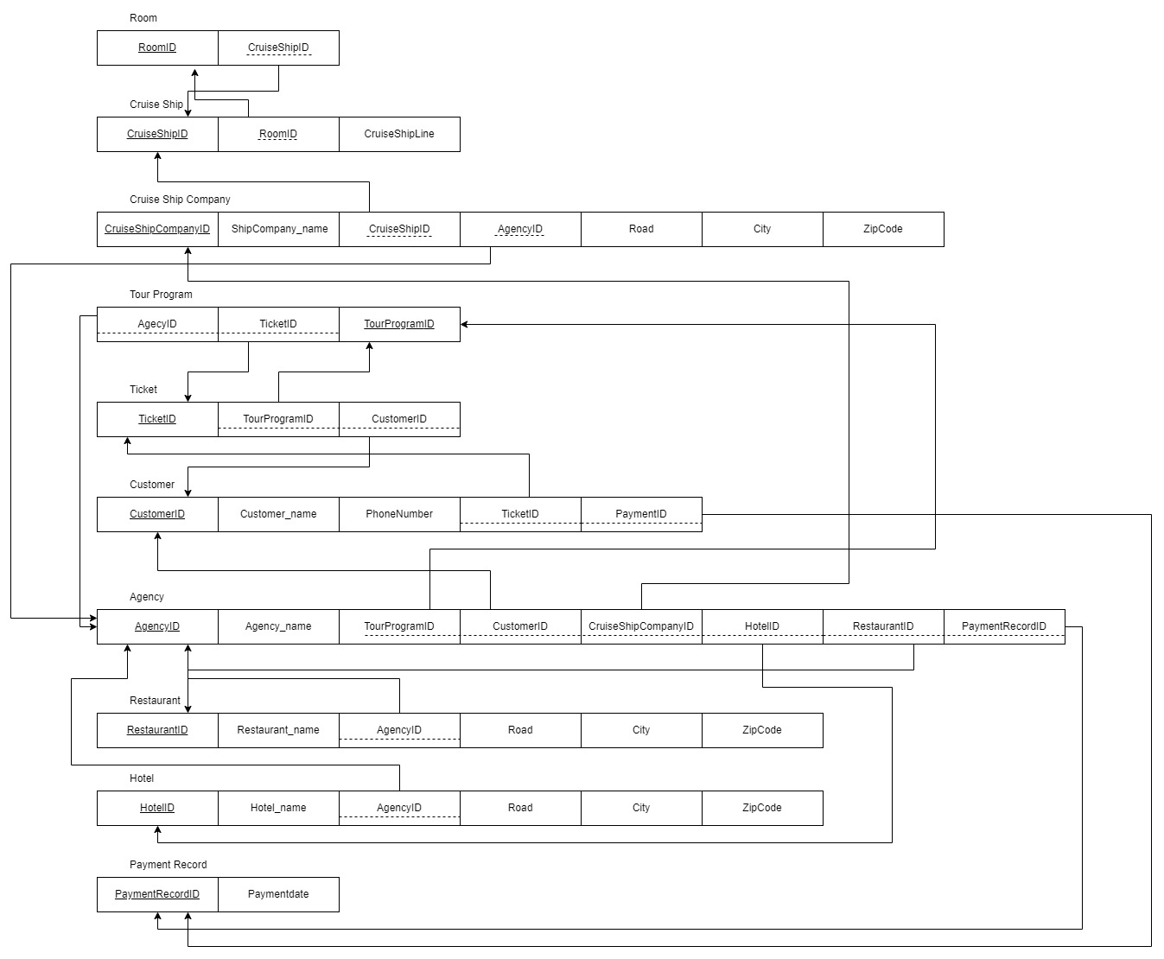

**Second Normal Form (2NF):**

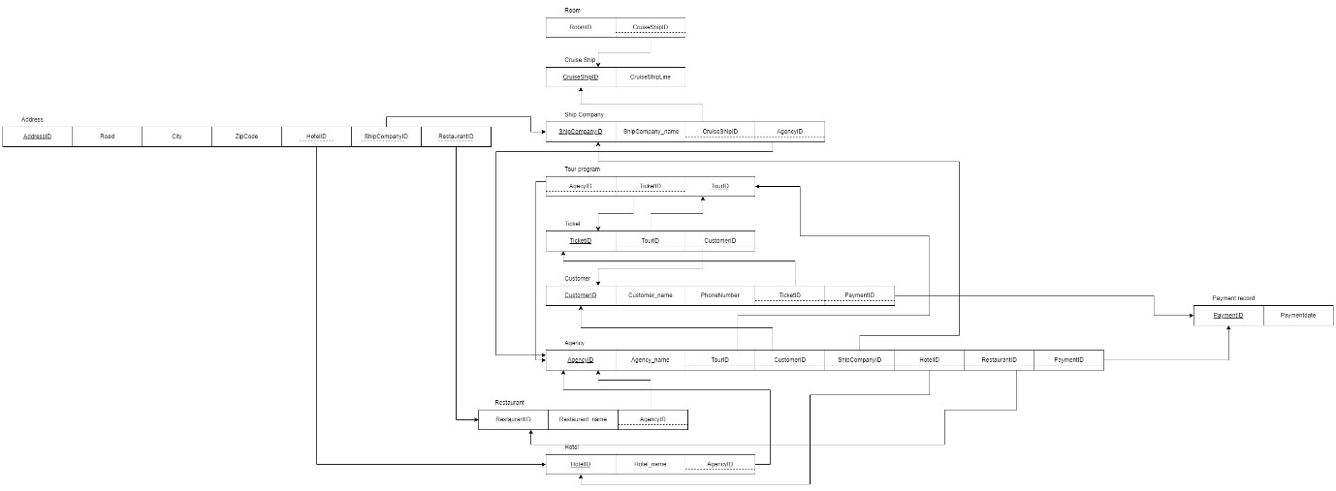

**Third Normal Form (3NF):**

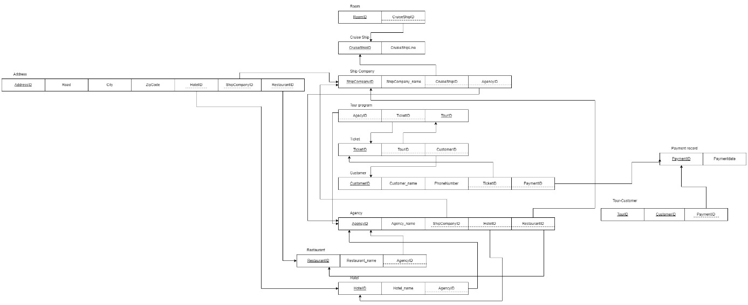

# **Unit 5 SQL Source Code**

**SQL Source Code for Create Database:**

**INSERT INTO address (addressID, road, city, zipcode) VALUES**

**(1, 'Chiang Mai', 'Mai', 121231),**

**(2, 'Main St', 'Bangkok', 10110),**

**(3, 'Ocean Ave', 'Phuket', 83100),**

**(4, 'Harbor Rd', 'Pattaya', 20150),**

**(5, 'Beachfront Blvd', 'Krabi', 81000),**

**(6, 'Hilltop Ln', 'Chiang Mai', 50200),**

**(7, 'Temple St', 'Ayutthaya', 13000),**

**(8, 'Market Ave', 'Surat Thani', 84000),**

**(9, 'Coconut Dr', 'Koh Samui', 84320),**

**(10, 'Sunset Way', 'Hua Hin', 77110),**

**(11, 'Palm Rd', 'Trang', 92000),**

**(12, 'Jungle Path', 'Kanchanaburi', 71000),**

**(13, 'Riverwalk', 'Nakhon Sawan', 60000),**

**(14, 'Historic Ln', 'Lopburi', 15000),**

**(15, 'Seaside St', 'Chonburi', 20000),**

**(16, 'Cultural Way', 'Udon Thani', 41000),**

**(17, 'Hillcrest Dr', 'Nakhon Ratchasima', 30000),**

**(18, 'Ancient Blvd', 'Sukhothai', 64000),**

**(19, 'Lakeside Rd', 'Nong Khai', 43000),**

**(20, 'Mountainview Dr', 'Mae Hong Son', 58000);**

**INSERT INTO agency (agencyID, agencyName, tourProgramID, customerID, cruiseShipCompanyID, restaurantID, hotelID, paymentRecordID) VALUES**

**(1, 'For Thai', 1-20, 1-20, 1-20, 1-20, 1-20, 1-20);**

**delete from agency where tourProgramID between 1 and 20;**

**INSERT INTO cruiseship (cruiseShipID, cruiseShipLine, roomID) VALUES**

**(1, 'Caribbean Explorer', 1),**

**(2, 'Pacific Voyager', 2),**

**(3, 'Atlantic Dream', 3),**

**(4, 'Mediterranean Pearl', 4),**

**(5, 'Baltic Star', 5),**

**(6, 'Indian Ocean Breeze', 6),**

**(7, 'Arctic Sun', 7),**

**(8, 'Antarctic Quest', 8),**

**(9, 'Pacific Spirit', 9),**

**(10, 'Northern Lights', 10),**

**(11, 'Southern Cross', 11),**

**(12, 'Equator Adventure', 12),**

**(13, 'Tropic Breeze', 13),**

**(14, 'Amazon River Cruise', 14),**

**(15, 'Gulf Stream', 15),**

**(16, 'Coral Explorer', 16),**

**(17, 'Sunset Queen', 17),**

**(18, 'Misty Isles', 18),**

**(19, 'Paradise Bay', 19),**

**(20, 'Lagoon Explorer', 20);**

**INSERT INTO cruiseshipcompany (cruiseShipCompanyID, cruiseShipCompanyName, cruiseShipID, agencyID, addressID) VALUES**

**(1, 'Royal Seas', 1, 1, 1),**

**(2, 'Oceanic Line', 2, 1, 2),**

**(3, 'Tropical Cruises', 3, 1, 3),**

**(4, 'Sea Voyager', 4, 1, 4),**

**(5, 'Marine Bliss', 5, 1, 5),**

**(6, 'Blue Waters', 6, 1, 6),**

**(7, 'Coral Line', 7, 1, 7),**

**(8, 'Wave Crest', 8, 1, 8),**

**(9, 'Star Marine', 9, 1, 9),**

**(10, 'Sunshine Cruises', 10, 1, 10),**

**(11, 'Azure Lines', 11, 1, 11),**

**(12, 'Paradise Fleet', 12, 1, 12),**

**(13, 'Ocean Wonders', 13, 1, 13),**

**(14, 'Voyage Ventures', 14, 1, 14),**

**(15, 'Harbor Tours', 15, 1, 15),**

**(16, 'Explorer Lines', 16, 1, 16),**

**(17, 'Seabreeze Corp', 17, 1, 17),**

**(18, 'Wave Horizon', 18, 1, 18),**

**(19, 'Aqua Expeditions', 19, 1, 19),**

**(20, 'Mermaid Fleet', 20, 1, 20);**

**delete from criuseShipCompany where cruiseShipCompanyID between 1 and 20;**

**INSERT INTO customer (customerID, customerName, phoneNumber, paymentRecordID, ticketID) VALUES**

**(1, 'John Doe', '0801234567', 1, 1),**

**(2, 'Jane Smith', '0812345678', 2, 2),**

**(3, 'Mike Johnson', '0823456789', 3, 3),**

**(4, 'Sara Davis', '0834567890', 4, 4),**

**(5, 'Linda Brown', '0845678901', 5, 5),**

**(6, 'James White', '0856789012', 6, 6),**

**(7, 'Patricia Black', '0867890123', 7, 7),**

**(8, 'Robert Green', '0878901234', 8, 8),**

**(9, 'Barbara Adams', '0889012345', 9, 9),**

**(10, 'Michael Allen', '0890123456', 10, 10),**

**(11, 'Elizabeth Young', '0811122334', 11, 11),**

**(12, 'David King', '0822233445', 12, 12),**

**(13, 'Susan Scott', '0833344556', 13, 13),**

**(14, 'Joseph Hill', '0844455667', 14, 14),**

**(15, 'Nancy Wright', '0855566778', 15, 15),**

**(16, 'Lisa Nelson', '0866677889', 16, 16),**

**(17, 'Thomas Baker', '0877788990', 17, 17),**

**(18, 'Karen Gonzalez', '0888899001', 18, 18),**

**(19, 'Chris Perez', '0899900112', 19, 19),**

**(20, 'Betty Roberts', '0810022033', 20, 20);**

**INSERT INTO hotel (hotelID, hotelName, agencyID, addressID) VALUES**

**(1, 'Ocean View Hotel', 1, 3),**

**(2, 'Seaside Inn', 1, 2),**

**(3, 'Palm Breeze Hotel', 1, 4),**

**(4, 'Lagoon Resort', 1, 5),**

**(5, 'Sunset Lodge', 1, 6),**

**(6, 'Island Escape', 1, 7),**

**(7, 'Mountain Retreat', 1, 8),**

**(8, 'Tropical Haven', 1, 9),**

**(9, 'Beachside Villa', 1, 10),**

**(10, 'Jungle Paradise', 1, 11),**

**(11, 'Harbor House', 1, 12),**

**(12, 'Riverbank Suites', 1, 13),**

**(13, 'Cliffside Hotel', 1, 14),**

**(14, 'Historic Inn', 1, 15),**

**(15, 'Coral Reef Hotel', 1, 16),**

**(16, 'Sand Dunes Resort', 1, 17),**

**(17, 'Coconut Grove', 1, 18),**

**(18, 'Marina Bay Inn', 1, 19),**

**(19, 'Ancient Ruins Lodge', 1, 20),**

**(20, 'The Lighthouse', 1, 1);**

**delete from hotel where hotelID between 1 and 20;**

**INSERT INTO paymentrecord (paymentRecordID, paymentRecordDate, bookingID) VALUES**

**(1, '2024-10-01', 1),**

**(2, '2024-10-02', 2),**

**(3, '2024-10-03', 3),**

**(4, '2024-10-04', 4),**

**(5, '2024-10-05', 5),**

**(6, '2024-10-06', 6),**

**(7, '2024-10-07', 7),**

**(8, '2024-10-08', 8),**

**(9, '2024-10-09', 9),**

**(10, '2024-10-10', 10),**

**(11, '2024-10-11', 11),**

**(12, '2024-10-12', 12),**

**(13, '2024-10-13', 13),**

**(14, '2024-10-14', 14),**

**(15, '2024-10-15', 15),**

**(16, '2024-10-16', 16),**

**(17, '2024-10-17', 17),**

**(18, '2024-10-18', 18),**

**(19, '2024-10-19', 19),**

**(20, '2024-10-20', 20);**

**delete from paymentRecord where paymentRecordID between 1 and 20;**

**INSERT INTO restaurant (restaurantID, restaurantName, agencyID, addressID) VALUES**

**(1, 'Seafood Delight', 1, 1),**

**(2, 'Tropical Bites', 1, 3),**

**(3, 'Harbor Grille', 1, 4),**

**(4, 'Ocean Feast', 1, 5),**

**(5, 'Sunset Diner', 1, 6),**

**(6, 'Island BBQ', 1, 7),**

**(7, 'Coral Cafe', 1, 8),**

**(8, 'Seaside Eats', 1, 9),**

**(9, 'Marina Bar', 1, 10),**

**(10, 'Coastal Kitchen', 1, 11),**

**(11, 'Bay Breeze', 1, 12),**

**(12, 'Tide Table', 1, 13),**

**(13, 'Beachside Bistro', 1, 14),**

**(14, 'Palm Pavilion', 1, 15),**

**(15, 'The Shell Shack', 1, 16),**

**(16, 'Wave House', 1, 17),**

**(17, 'Shoreline Cafe', 1, 18),**

**(18, 'Cove Restaurant', 1, 19),**

**(19, 'The Pier Eatery', 1, 20),**

**(20, 'Sailor’s Galley', 1, 2);**

**delete from restaurant where restaurantID between 1 and 20;**

**INSERT INTO ticket (ticketID, tourProgramID, customerID) VALUES**

**(1, 1, 1), (2, 2, 2), (3, 3, 3), (4, 4, 4), (5, 5, 5),**

**(6, 6, 6), (7, 7, 7), (8, 8, 8), (9, 9, 9), (10, 10, 10),**

**(11, 11, 11), (12, 12, 12), (13, 13, 13), (14, 14, 14), (15, 15, 15),**

**(16, 16, 16), (17, 17, 17), (18, 18, 18), (19, 19, 19), (20, 20, 20);**

**INSERT INTO tourprogram (tourProgramID, agencyID, ticketID) VALUES**

**(1, 1, 1), (2, 1, 2), (3, 1, 3), (4, 1, 4), (5, 1, 5),**

**(6, 1, 6), (7, 1, 7), (8, 1, 8), (9, 1, 9), (10, 1, 10),**

**(11, 1, 11), (12, 1, 12), (13, 1, 13), (14, 1, 14), (15, 1, 15),**

**(16, 1, 16), (17, 1, 17), (18, 1, 18), (19, 1, 19), (20, 1, 20);**

**delete from tourprogram where tourProgramID between 1 and 20;**

**INSERT INTO room (roomID, cruiseShipID) VALUES**

**(1, 1), (2, 2), (3, 3), (4, 4), (5, 5),**

**(6, 6), (7, 7), (8, 8), (9, 9), (10, 10),**

**(11, 11), (12, 12), (13, 13), (14, 14), (15, 15),**

**(16, 16), (17, 17), (18, 18), (19, 19), (20, 20);**

**INSERT INTO booking (bookingID, paymentRecordID, ticketID, customerID) VALUES**

**(1, 1, 1, 1),**

**(2, 2, 2, 2),**

**(3, 3, 3, 3),**

**(4, 4, 4, 4),**

**(5, 5, 5, 5),**

**(6, 6, 6, 6),**

**(7, 7, 7, 7),**

**(8, 8, 8, 8),**

**(9, 9, 9, 9),**

**(10, 10, 10, 10),**

**(11, 11, 11, 11),**

**(12, 12, 12, 12),**

**(13, 13, 13, 13),**

**(14, 14, 14, 14),**

**(15, 15, 15, 15),**

**(16, 16, 16, 16),**

**(17, 17, 17, 17),**

**(18, 18, 18, 18),**

**(19, 19, 19, 19),**

**(20, 20, 20, 20);**

**SQL Source Code for Create Tables:**

**SQL Source Code for Create Queries:**



